**BANKS**

**TO START  
1.) Menu  
2.) Maintenance  
3.) Banks**

Banks

Maintenance

Menu

33 1*1*

2 1*1*

1 1*1*

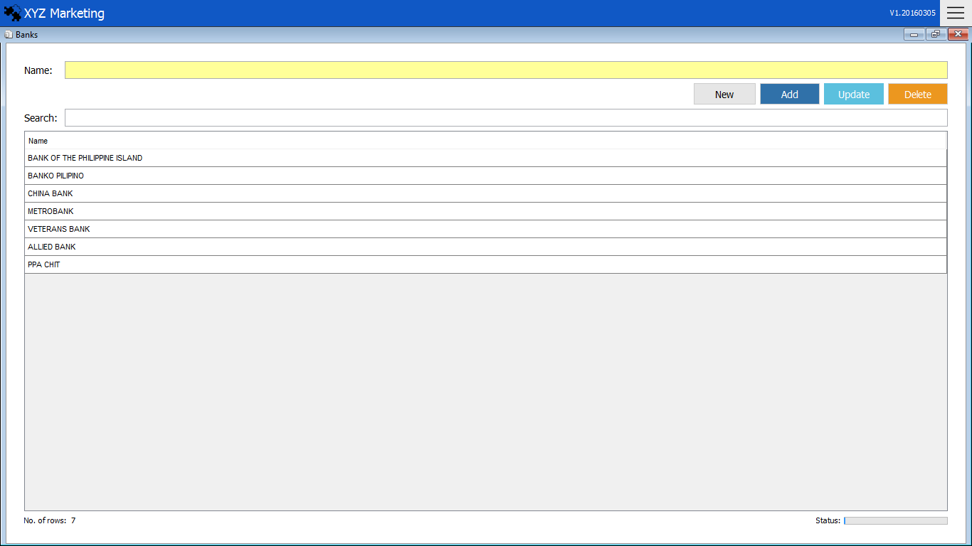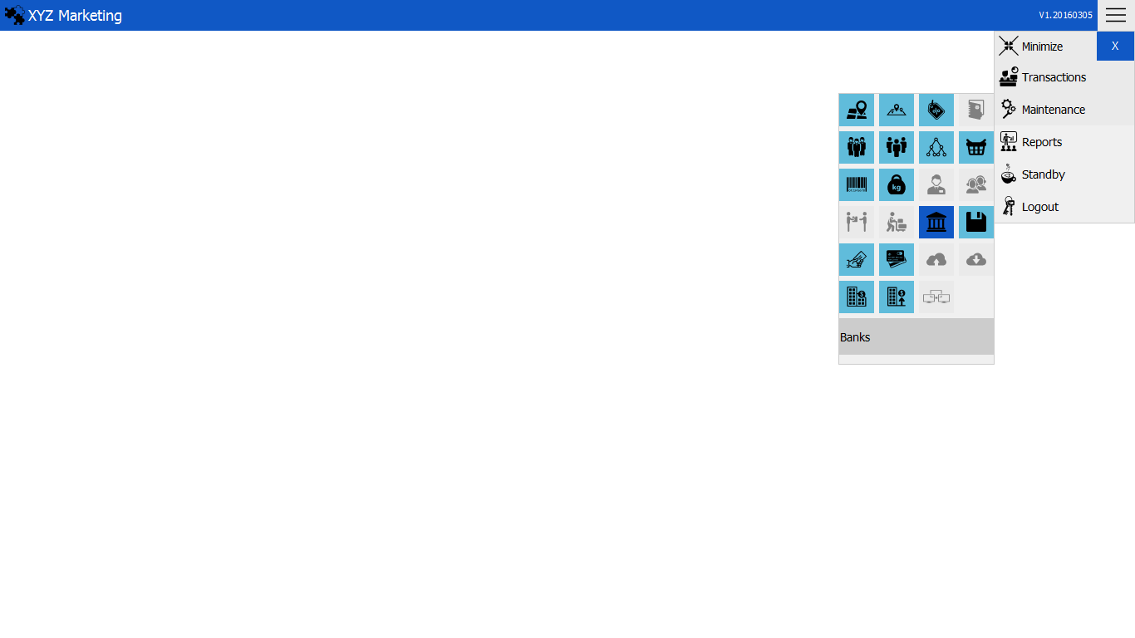

1 1*1*

**ADD NEW BANK  
1.) Input the name of the bank**

**2.) Add**

Add

Name of

the bank

2 1*1*

Search box

List of Banks

**1.) Input the name of the bank**

Input the name of the bank wanted to add.

**2.) Add,Update & Delete**

**2.1) Add**

After filling up the bank name, just click the add button to finish.

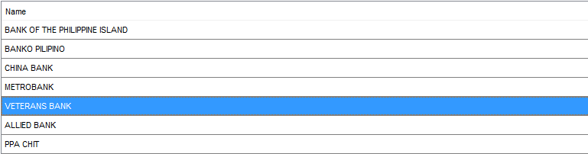**2.1) Update**



Click the update button to finish.

Input the updated name.

Click the name of the bank in the list that you want to update.

**2.2) Delete**



Click the delete button to finish.

Click the name of the bank that you wanted to delete.